**Phase 1 (minimum functionality)(8 hours)**

**Creating Admin Panel**

1. An input button where a user can input a tag name as shown in figure below.

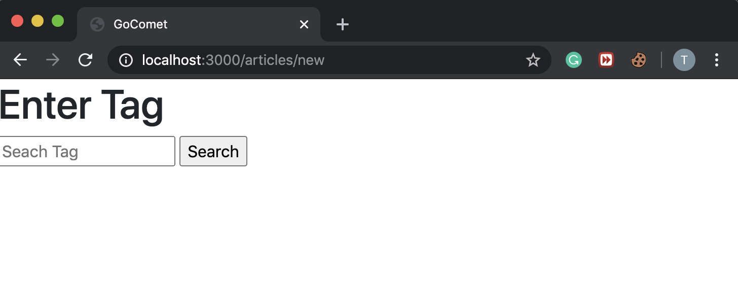

1. On submit it sends a request to the backend server to crawl for that particular tag.

**Using ‘Watir’ gem to crawl the data**

1. Medium pages are written using Javascript therefore to scrape the data we can not use gems like Nokogiri as it only works with static pages.
2. I decided to use Watir which is an open-source family of Ruby libraries for automating web browsers.
3. Watir can imitate web browsers therefore it can render Javascript.
4. The crawl method defined in the articles controller has the logic for crawling data from Medium.

**Database Design**

1. Articles Table

|  |  |
| --- | --- |
| Column Name | Type |
| Name | String |
| Title | String |
| Date | String |
| Time | String |
| Content | String |

1. Tag Table

|  |  |
| --- | --- |
| Column Name | Type |
| Tagname | String |
| Article_Id(Reference Articles)(FK) | Integer |

**UI (Twitter Bootstrap)**

1. Figure below shows the latest 10 articles for ‘Culture’ tag.

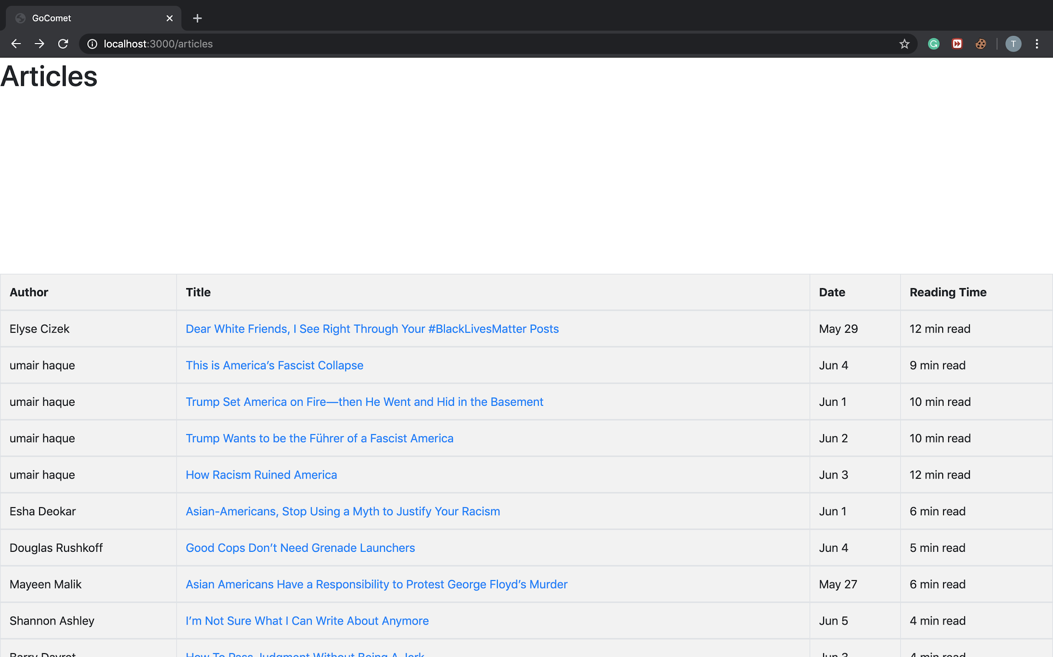

1. When a user clicks a particular article it opens in a new page (title, date, time, author, blog, tags, responses) (as it is displayed on the Medium Blog) as shown in figure below.

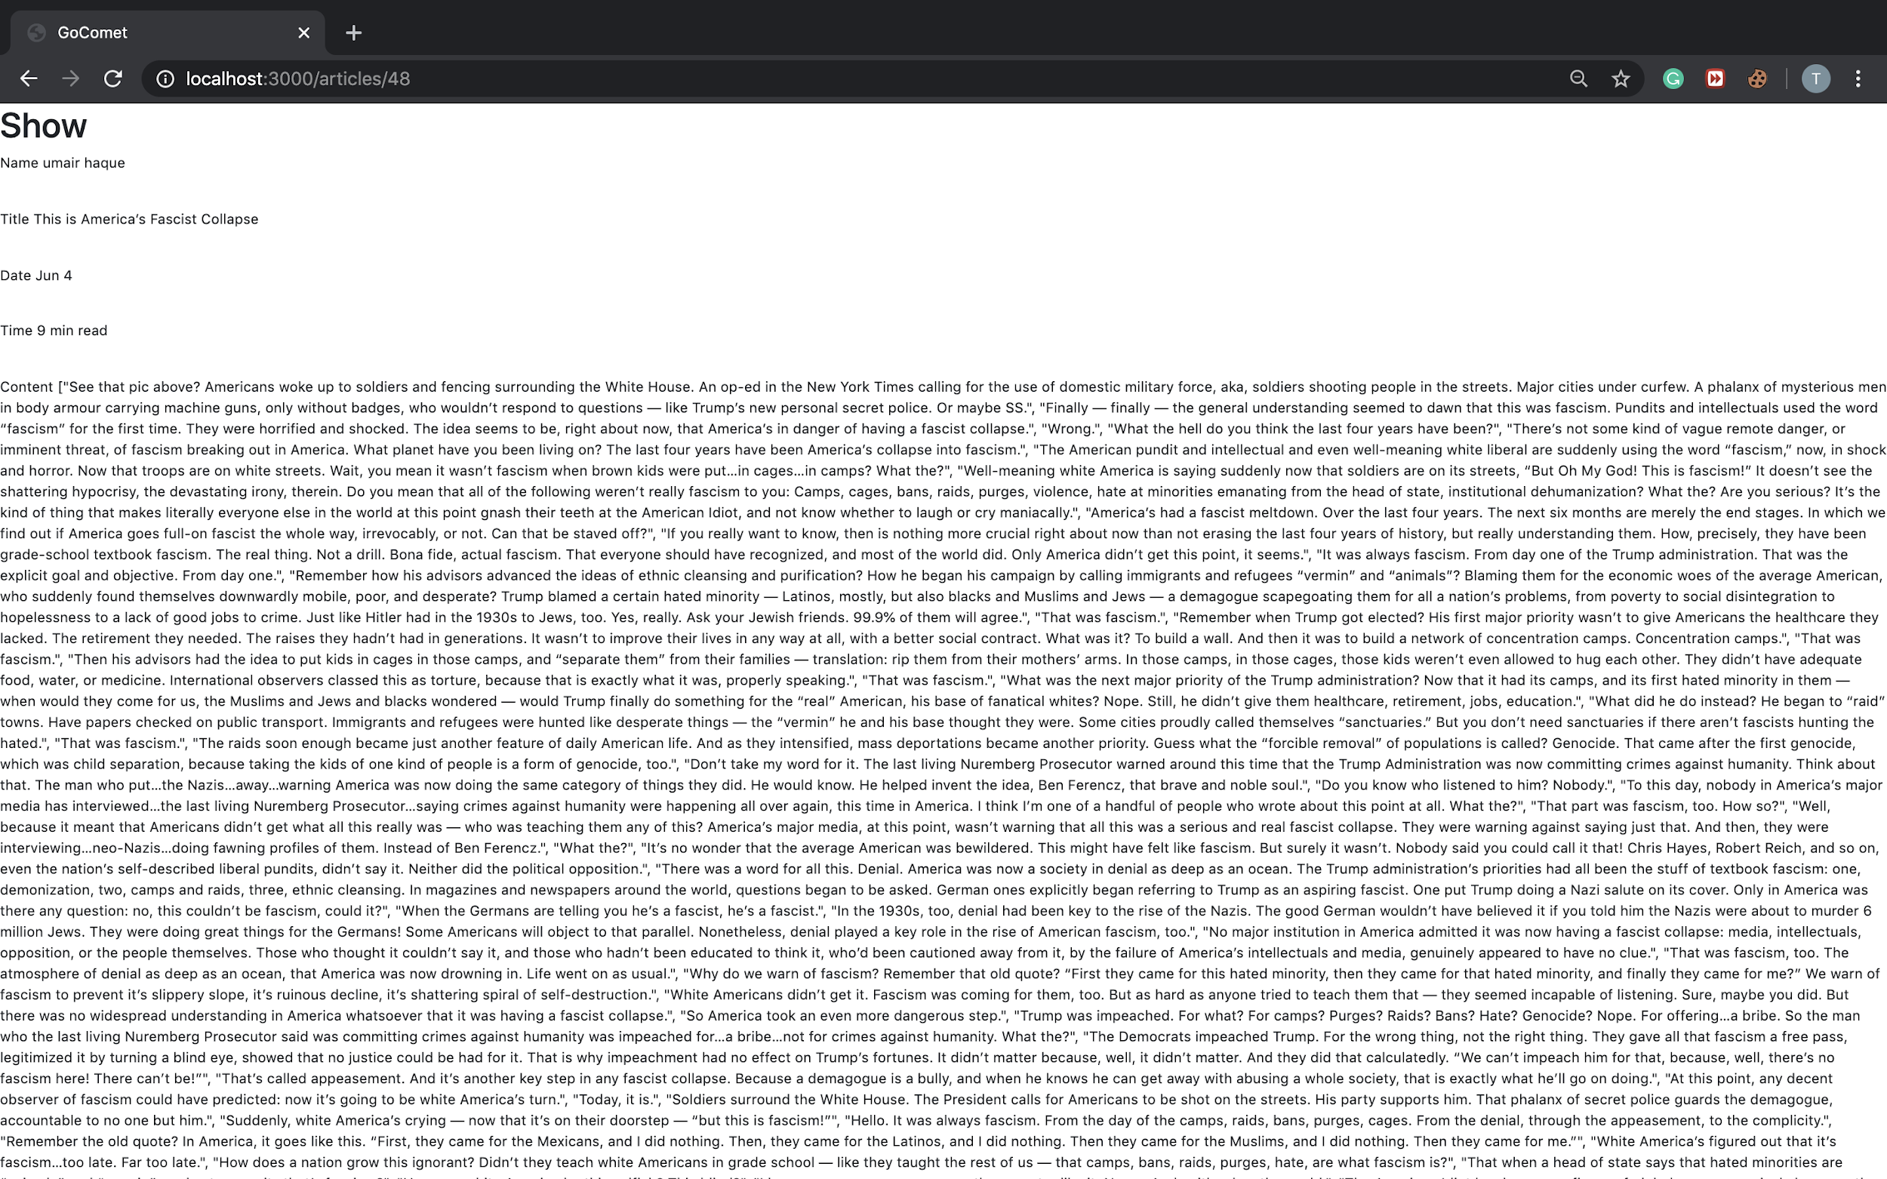

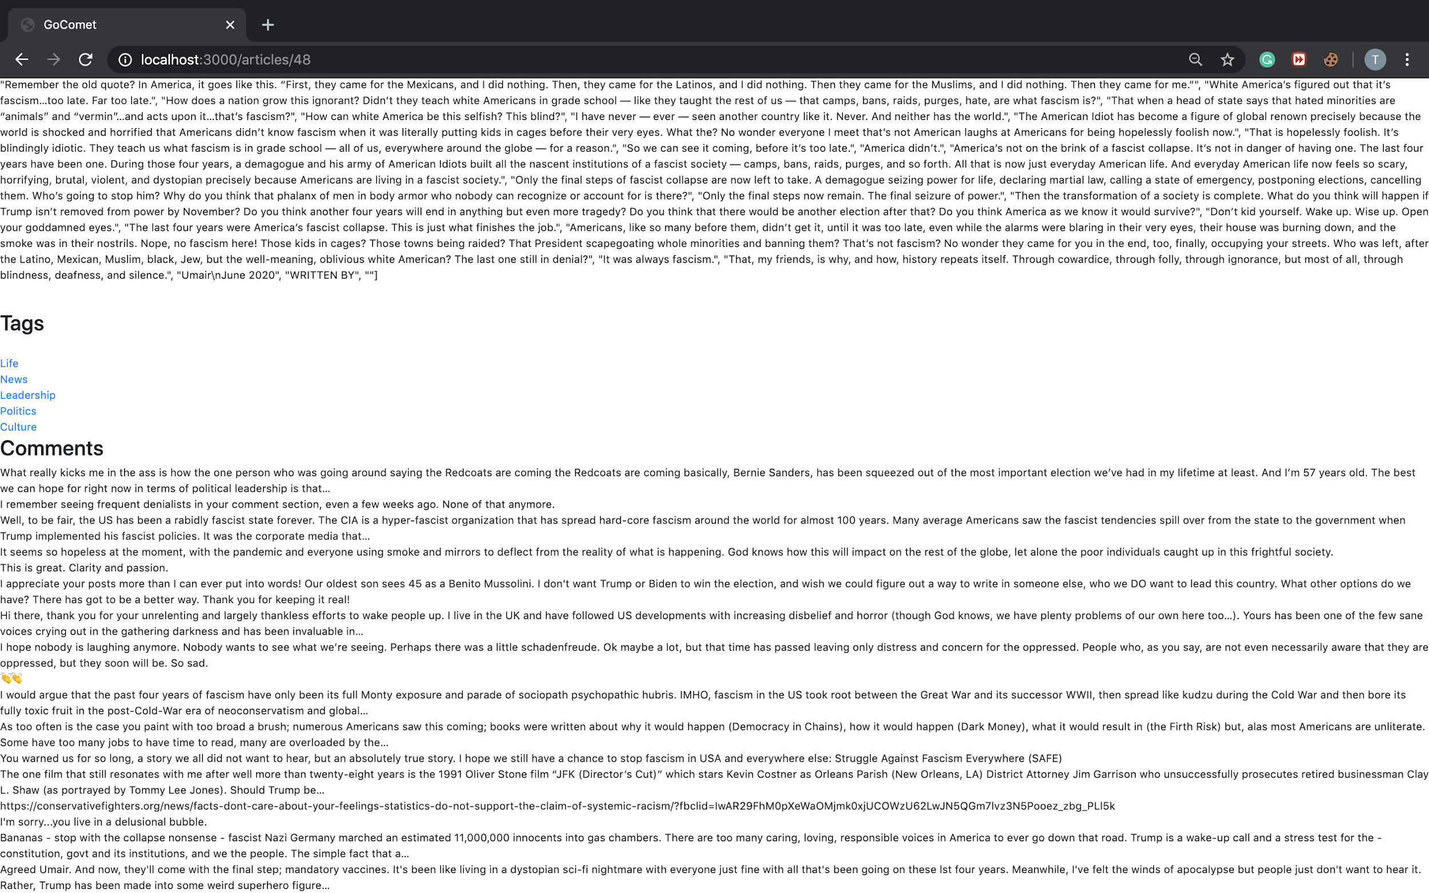

**Phase 2 (more advance features)(3 hours)**

**Crawl Responses for a Blog**

1. The responses of a blog are present on a separate link (available at the bottom of the page of the blog in medium).
2. In the figure below responses/comments are visible in the bottom left corner.

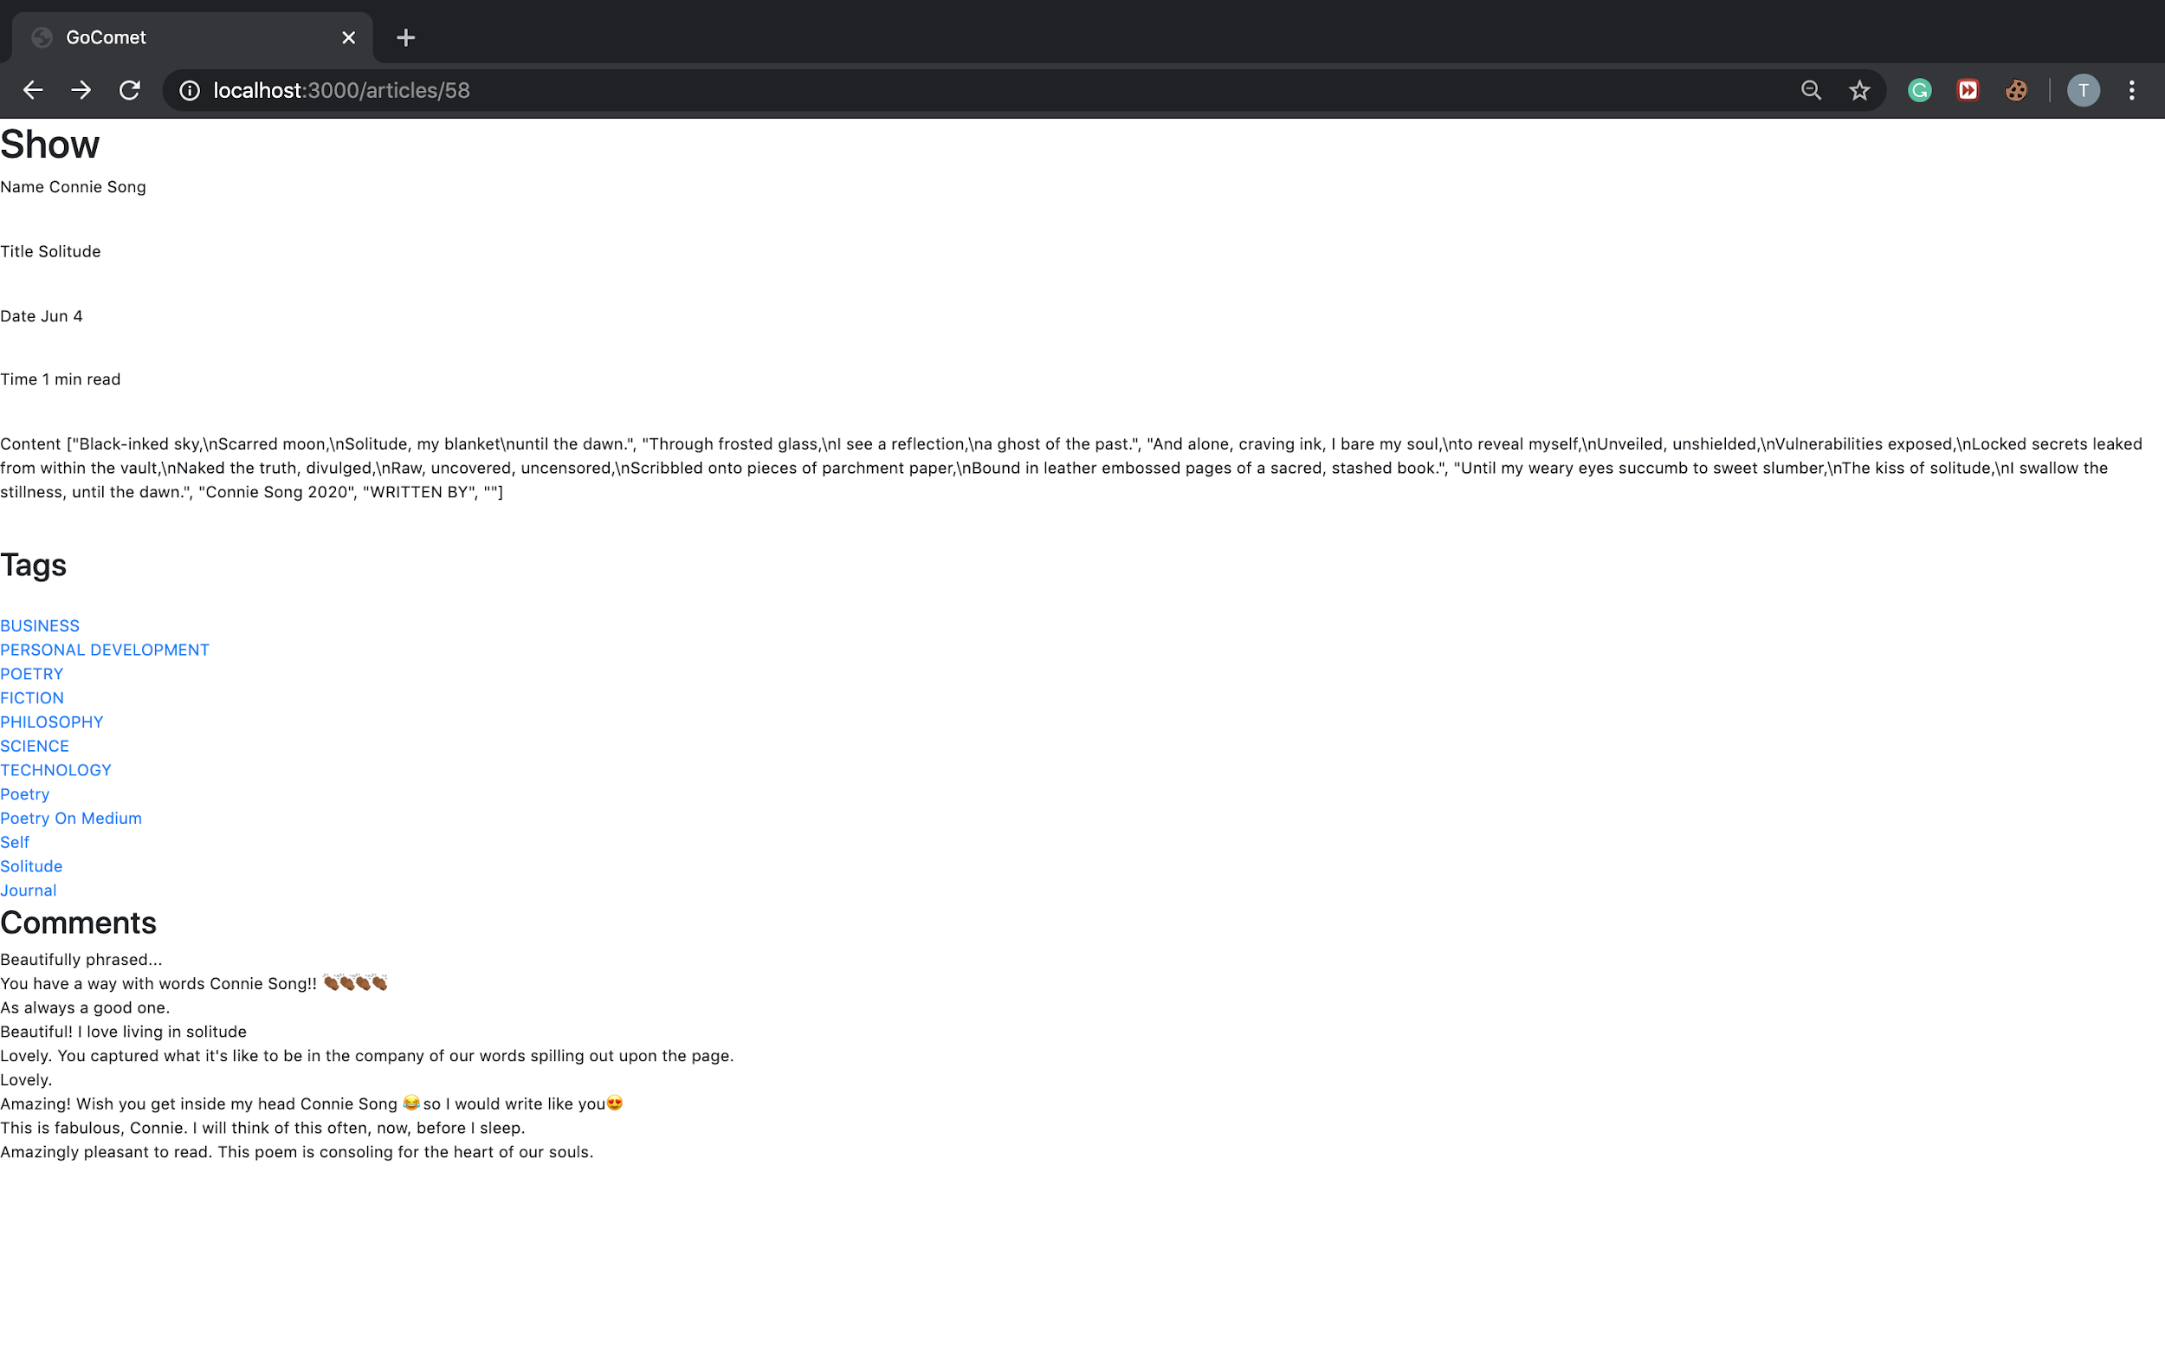

**Database Design**

1. Response Table

|  |  |
| --- | --- |
| Column Name | Type |
| ResponseContent | String |
| Article_Id(Reference Articles)(FK) | Integer |

**Next 10 Blogs**

1. There is an option of “next 10 blogs”, it crawls next 10 blogs with the above tag.
2. The figure below shows the option “next 10” at the bottom left corner of the screen.

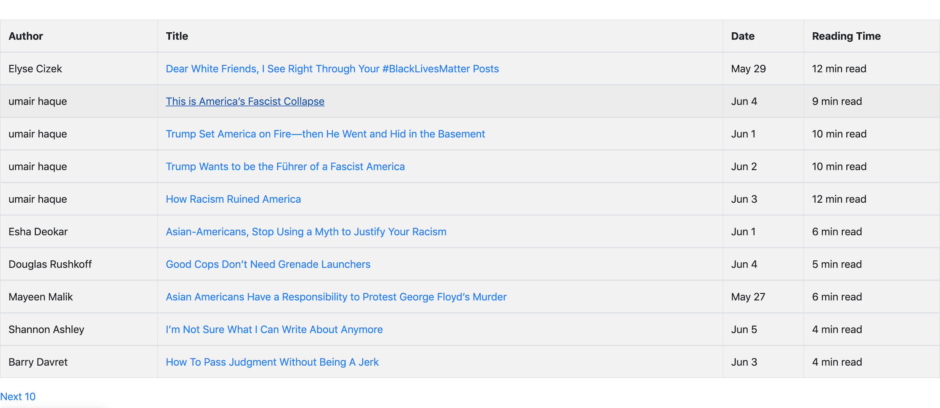

**Click a Tag Inside a Blog**

1. When a user clicks on a tag(inside a blog) then it crawls 10 latest blogs of that tag.
2. The figure below shows the tags for a particular blog.

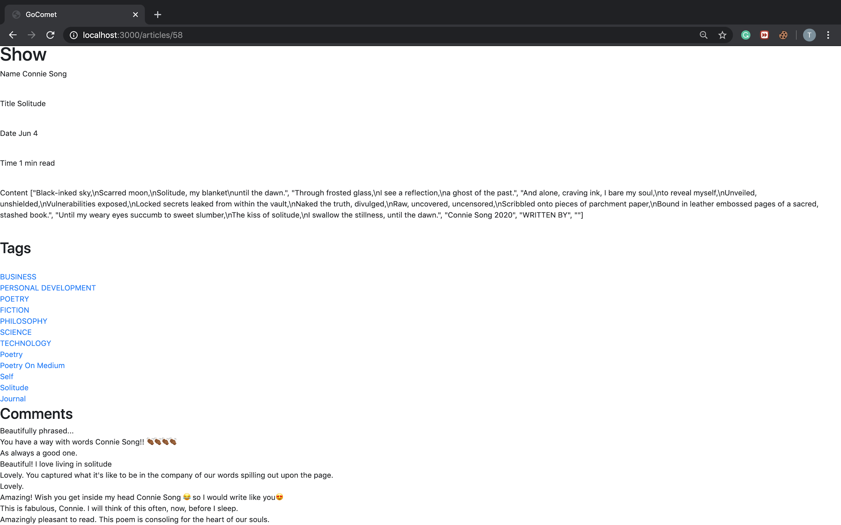

1. When we click on say “Fiction” it crawls the latest 10 blogs for ‘Fiction’ as shown in figure below.

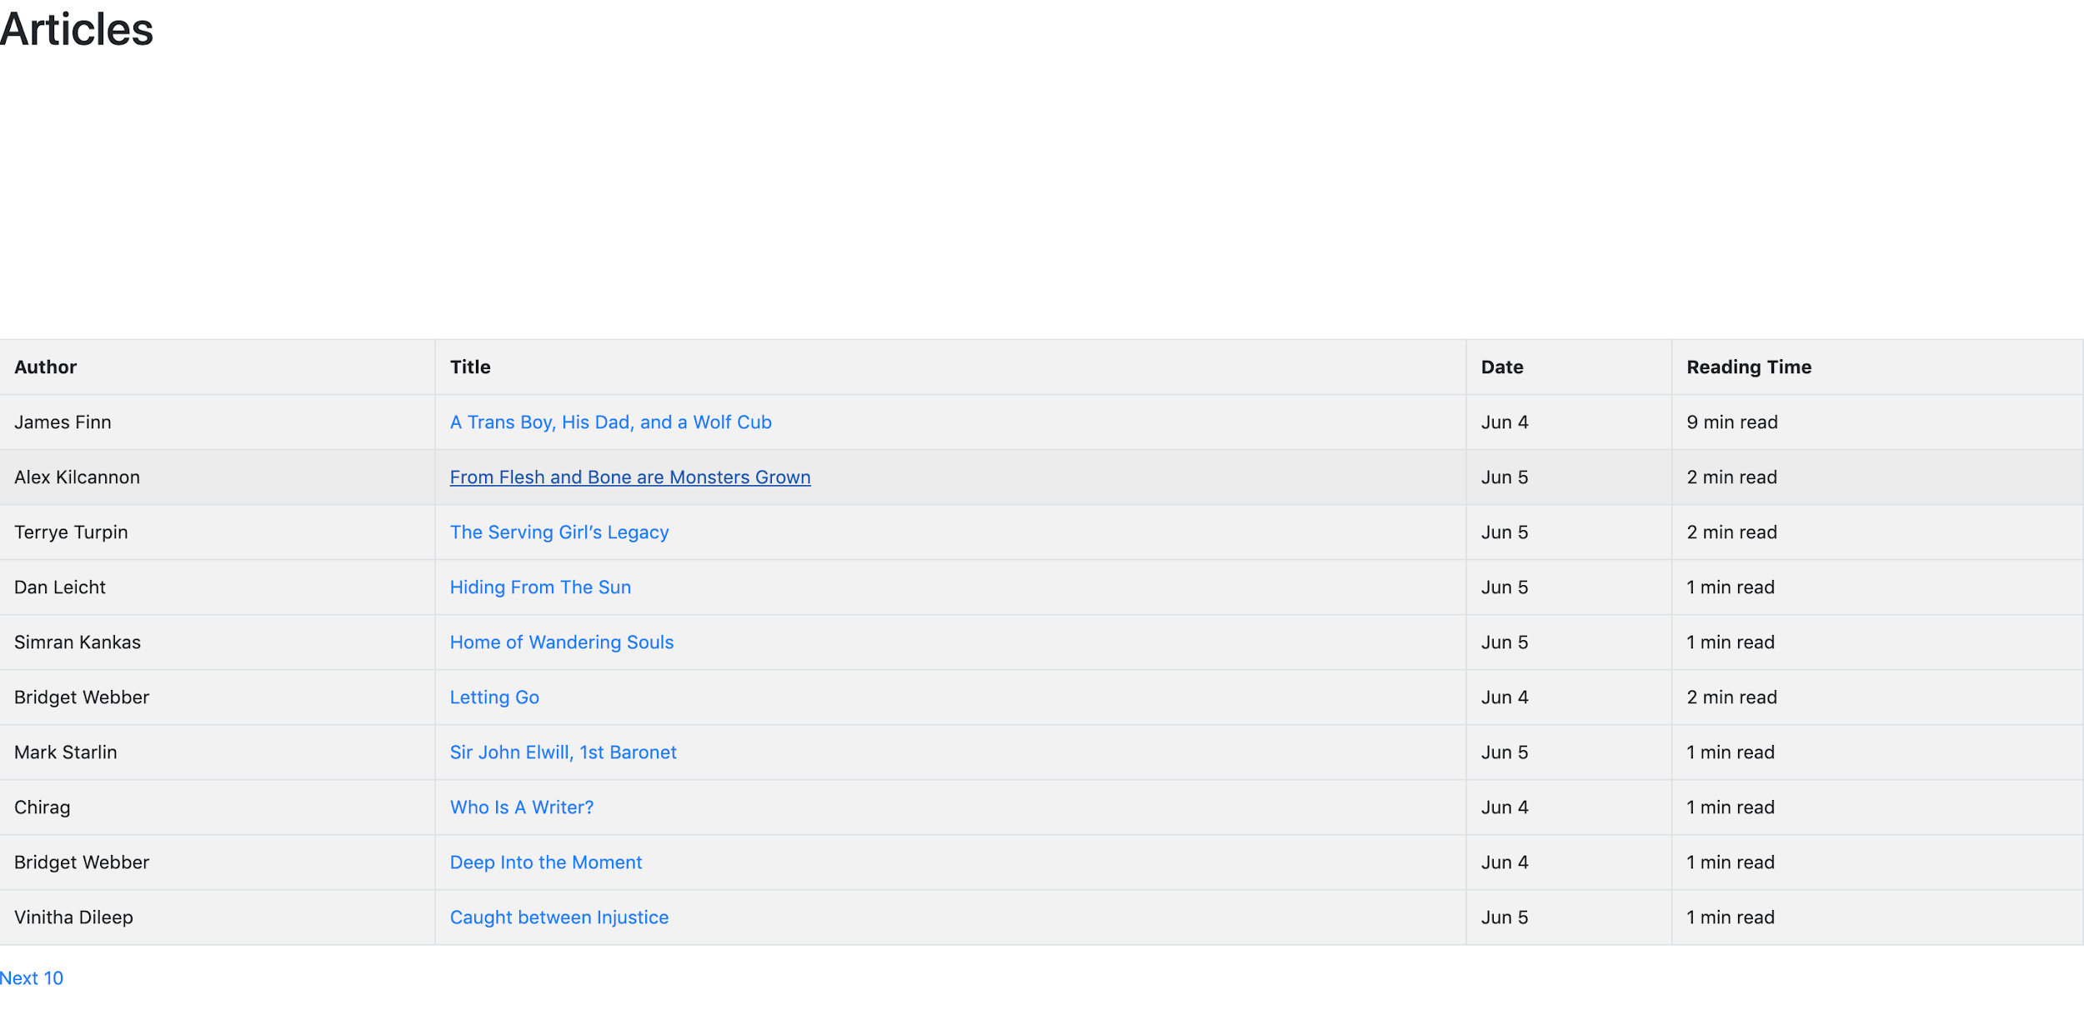

**Time Taken To Crawl Latest Blogs of a Tag**

1. How much time it took to crawl the latest blogs of a tag is shown in the bottom left corner in the figure below.

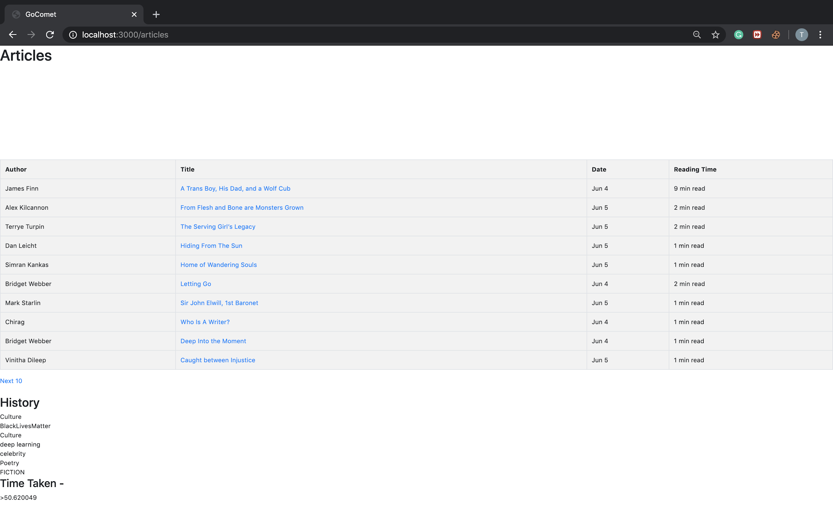

**Search History**

1. In the above figure under the ‘History’ heading we have the search history.
2. History Table

|  |  |
| --- | --- |
| Column Name | Type |
| Searchtag | String |